Design Plan -

Speech Capture, Transcription, and Analysis App

Sponsor – Dr. Zoran Djordjevic

Reed Cummings – Group Leader

Mario Jelev

Eric Rogers

James Lussier

Abstract

In this document we will go over design choices and the aesthetic of the software.

TABLE OF CONTENTS

List of Figures 4

List of Tables 14

Introduction 15

GUI Design 16

Static Model 19

Dynamic Model 23

Rationale for Our Architectural Style and Model 26

Evidence the Requirements have been Places Under Config Mgmt. 27

References 28

LIST OF FIGURES

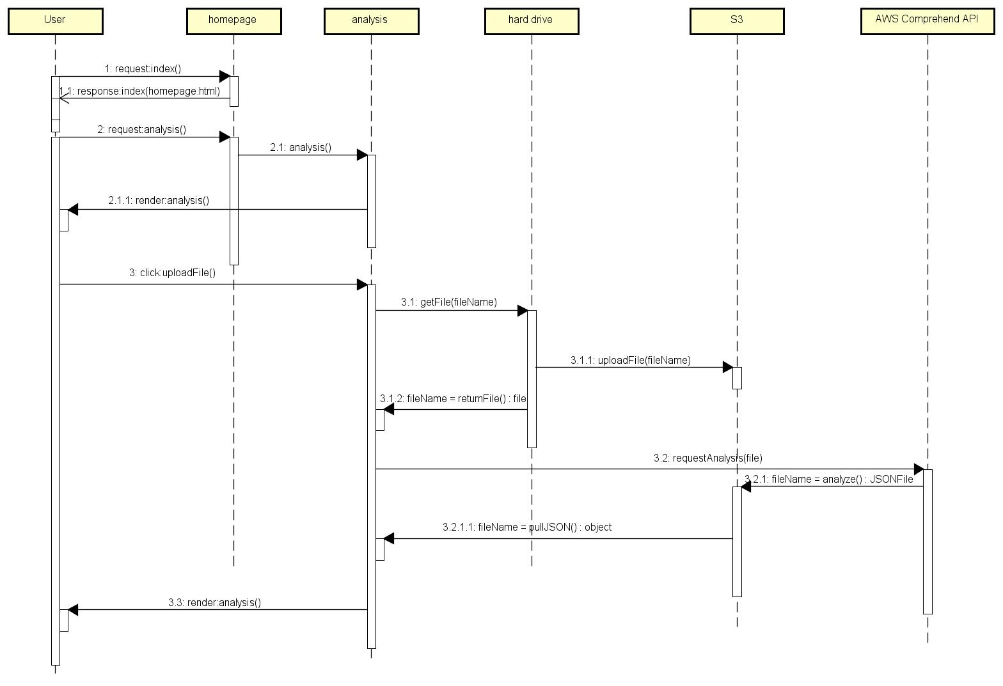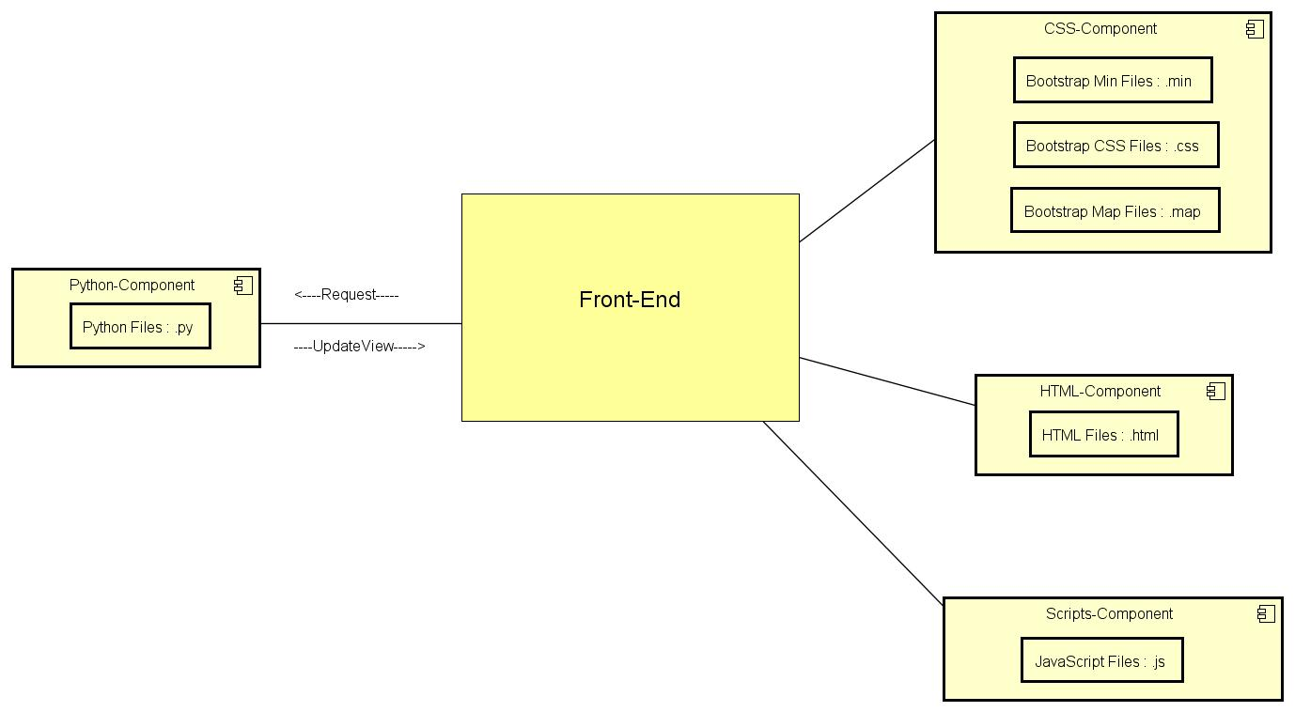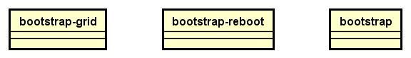

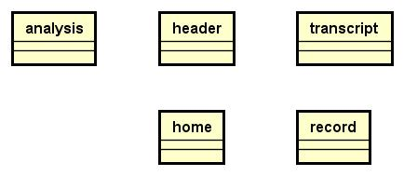

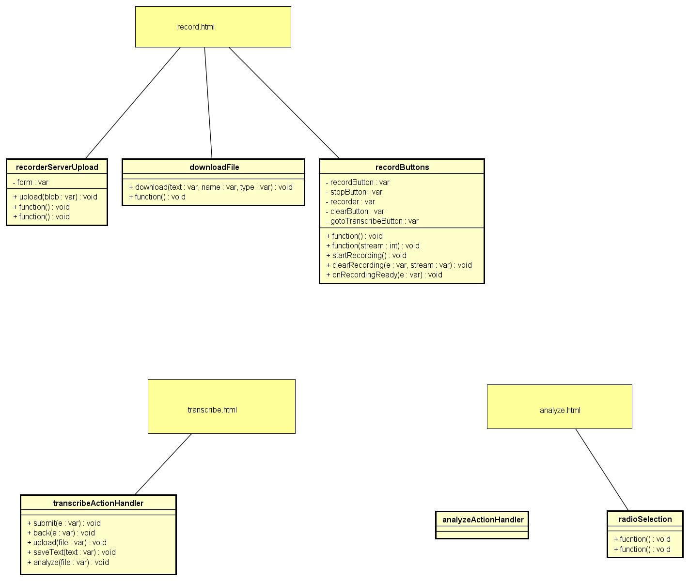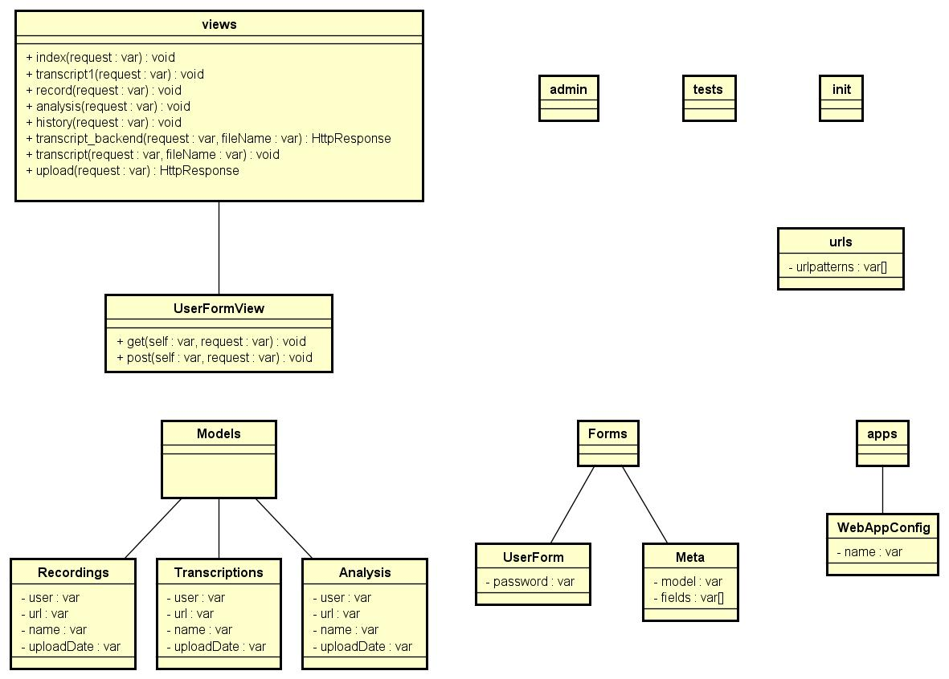

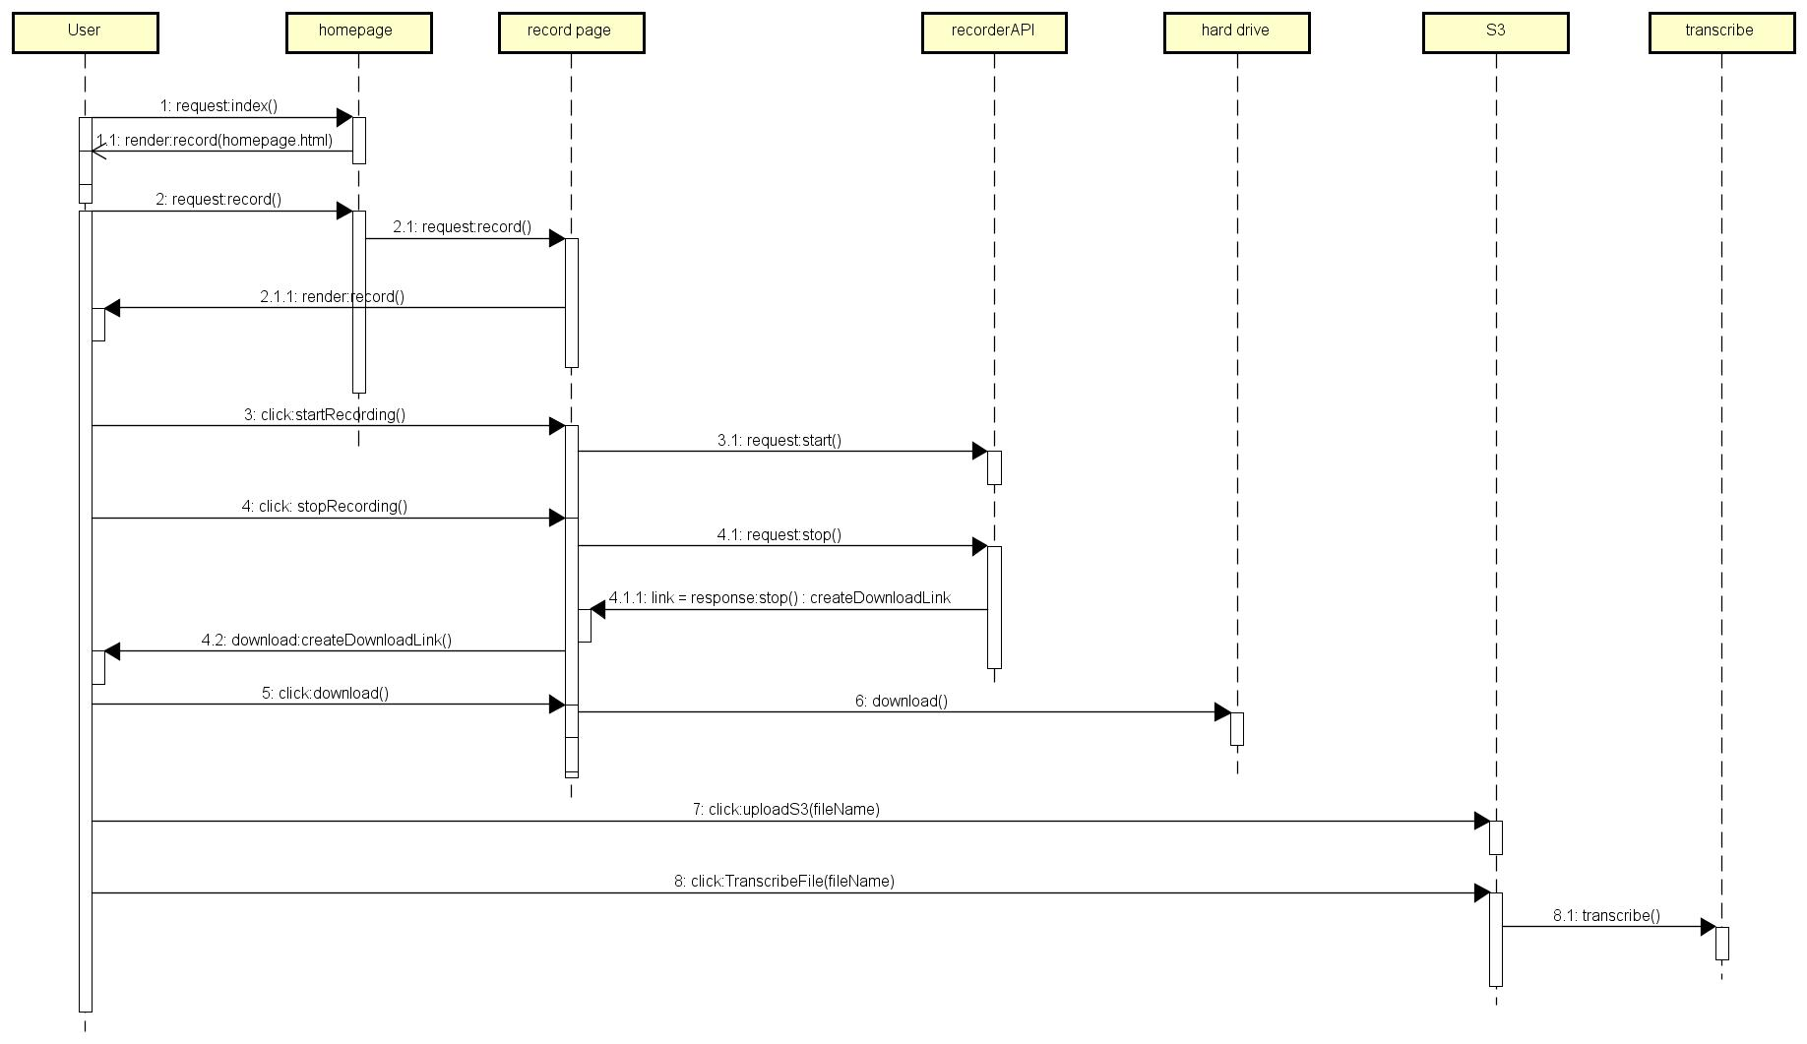

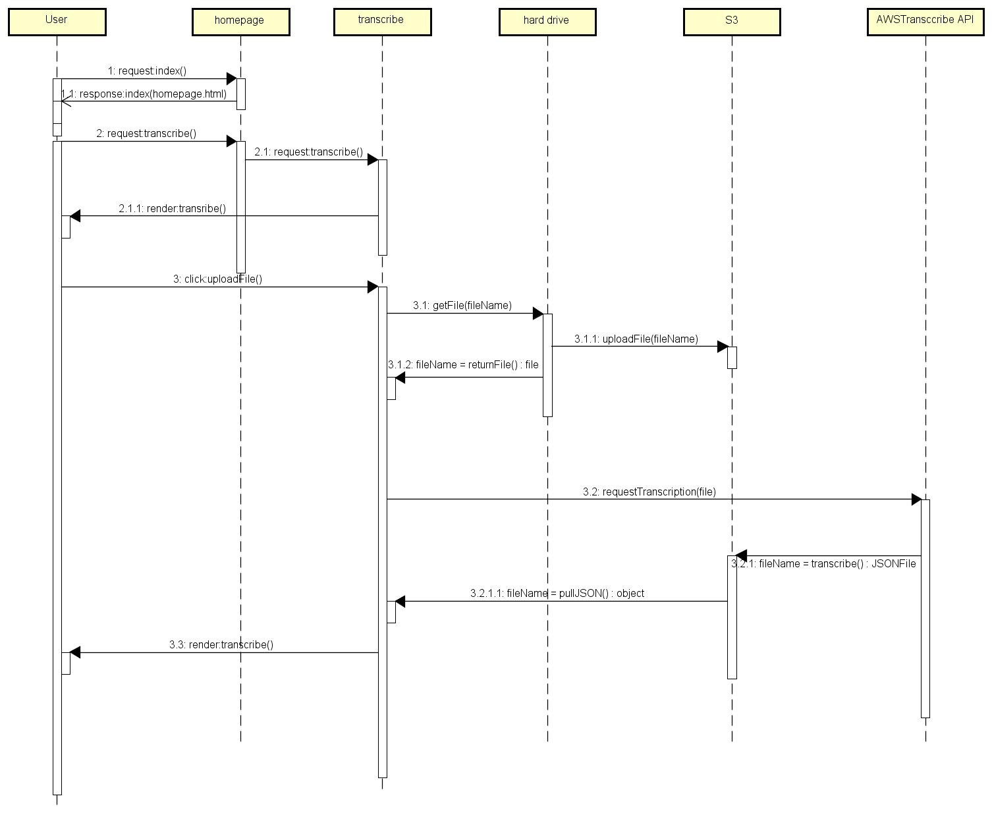

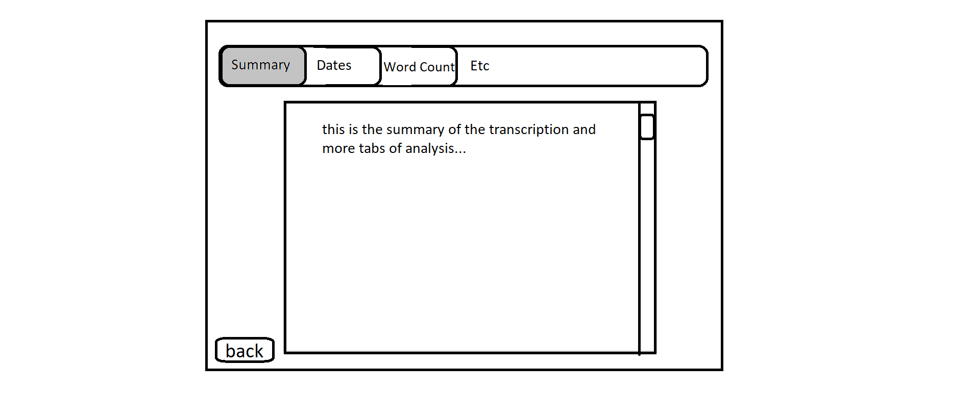

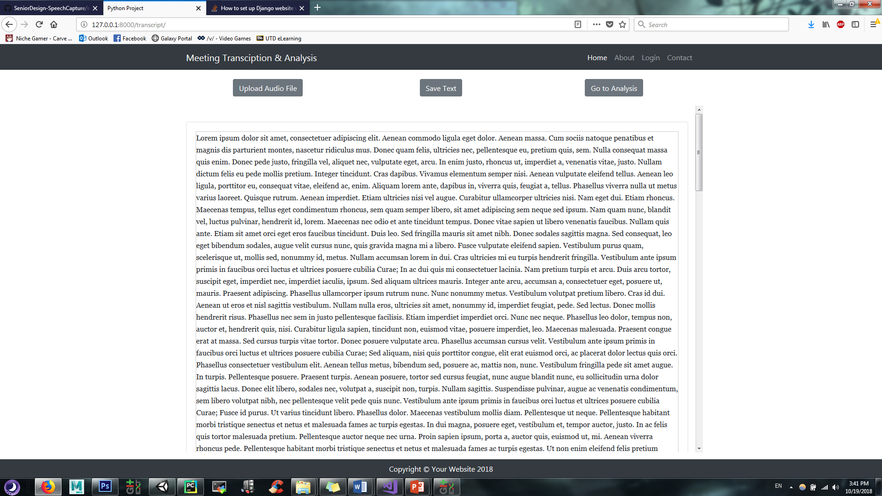

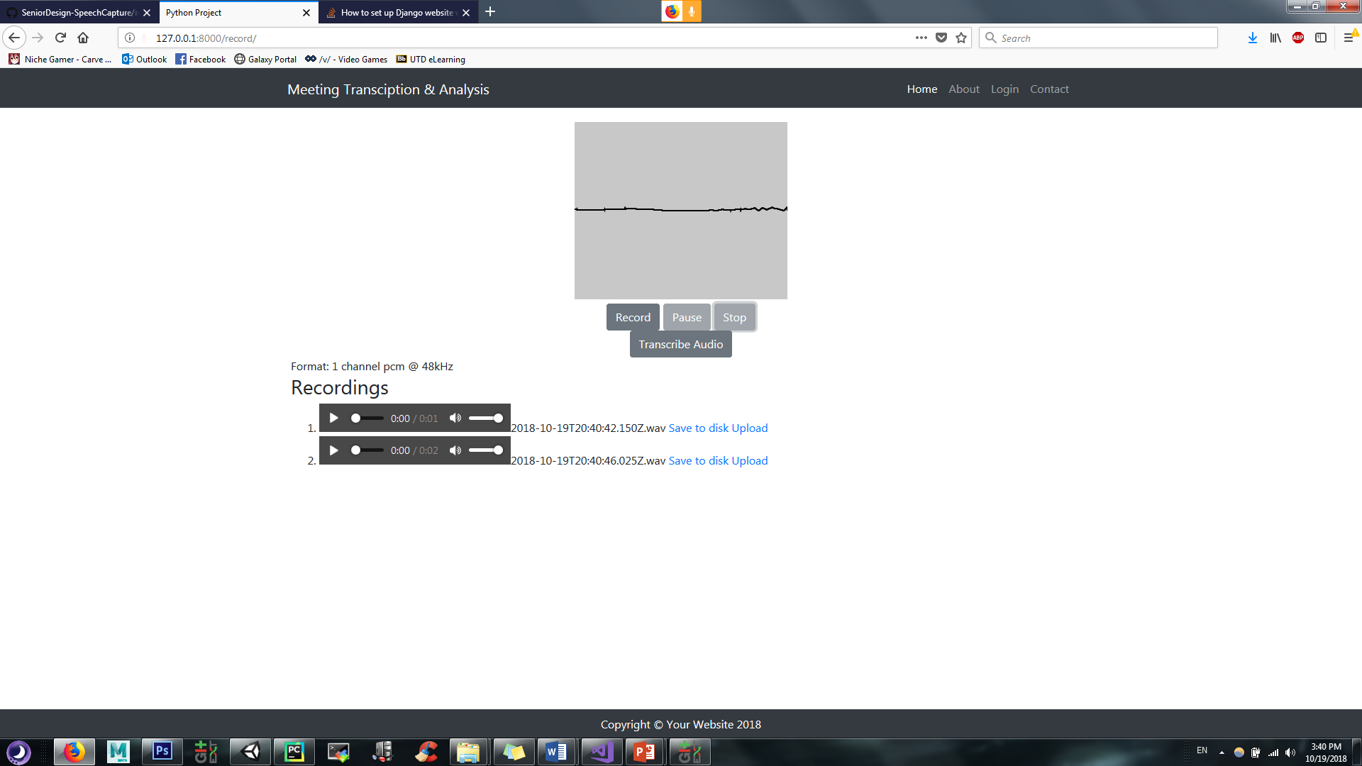

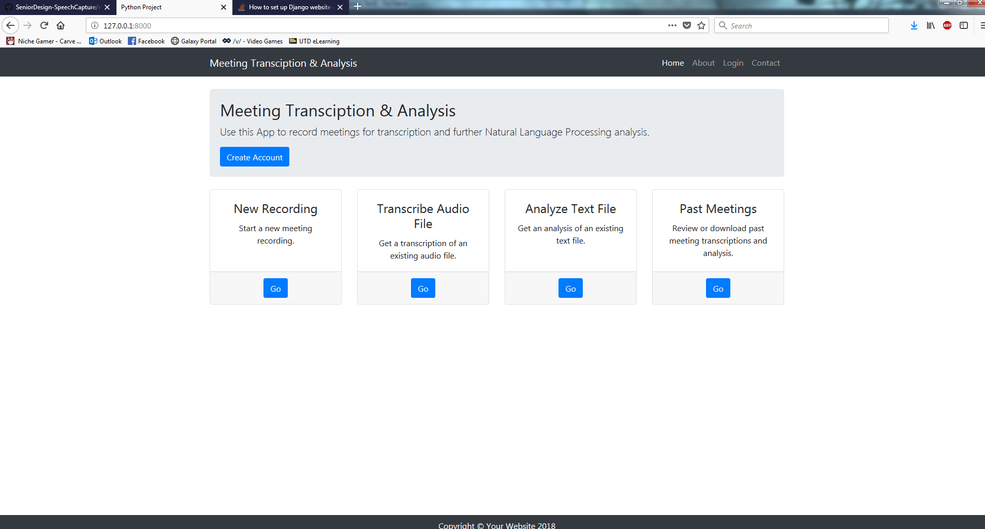

LIST OF TABLES

Introduction

The purpose of this document is to explain our design choices and show what the software will look like upon completion. To begin with, we will go over the graphical user interface of the software. We will then go over the preliminary static model for the design, and why we chose to do it as such. Next, we will go over the preliminary dynamic model for the design and why we chose to design it in this manner.

We will then explain the rationale behind the GUI and models interacting in the manner they do.

GUI Design

Below is our homepage, where you can choose which action to perform. You can create a new recording, transcribe an existing .mp3 file, analyze an already existing .txt file, and search past meetings (if you are logged in).



Below is our recording page. This is the page where you can record audio. It will show you past recordings (from this session) numbered at the bottom. The save to disk will download it, and the upload button will upload it to s3 AWS services.



Below is our transcription page. This will appear after a successful transcription.





The above is the mockup of our analysis page. It will have the same header as the other actual pages, and the tabs may have different types of analysis.

Static Model

Component Diagram from a high level



CSS files



HTML files



Below are the script files we use in JavasBelow are the

Below are the python files 

Dynamic Model

Record a file sequence diagram



Transcribe a file sequence diagram



Analyze a file sequence diagram



Rationale for our Detailed Design Model

We have chosen the design model because it is a heavy GUI application. We tried to model it after a Model-View-Controller type of design. With all of the GUI, we have scripts to control the actions performed on each webpage, which communicate with the python to load the screens.

EVIDENCE THE DOCUMENT HAS BEEN PLACED UNDER CONFIGURATION

MANAGEMENT

<https://github.com/reedpcummings/SeniorDesign-SpeechCapture>

REFERENCES